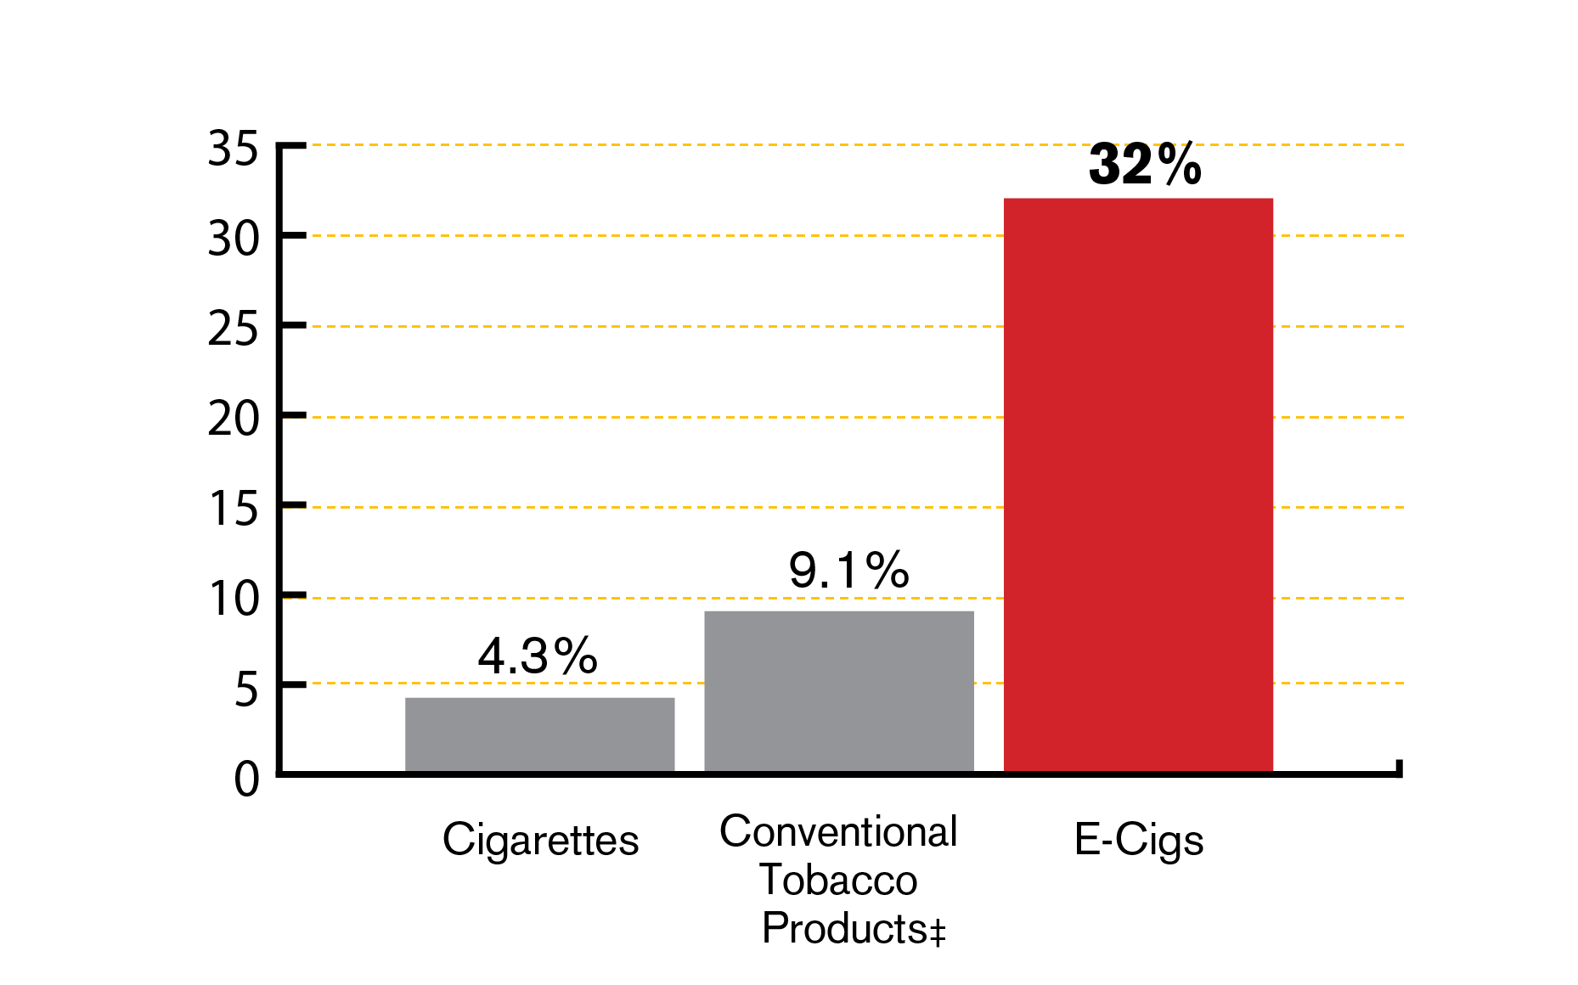 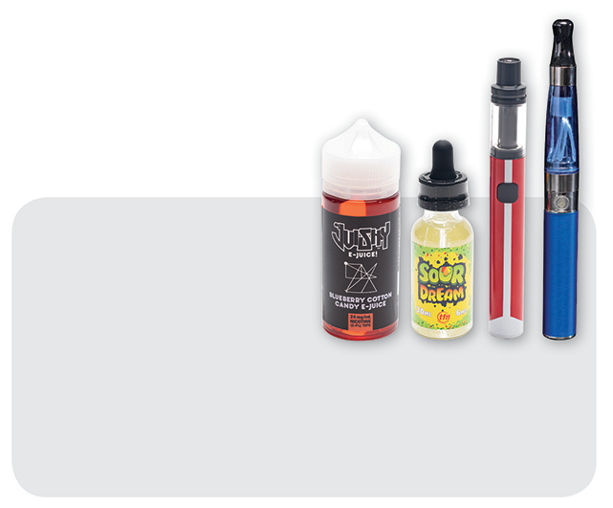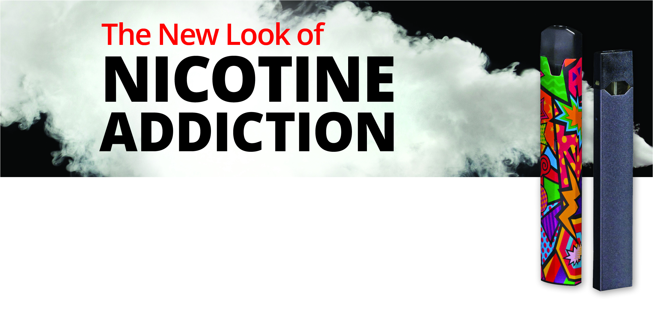

† Use in the past 30 days

‡ Conventional tobacco defined as cigarettes, cigars

(including little cigars and cigarillos), and smokeless tobacco (chewing tobacco, snuff, dip)

Source: 2019 MA Youth Health Survey. Data are provisional.

**Current**† **Use of Tobacco and Vaping   
Products by MA High School Youth, 2019**

**Contact**

For questions about the presentation or to register, please contact Name at Phone Number or email address.

**Title of Talk**

**Date**

**Time**

**Location, including room #**

32% of Massachusetts high school students report currently using e-cigarettes and vapes, and 52% tried them at least once.

Learn more about what these products are, why they are harmful, how to protect our kids, and how to help kids quit.