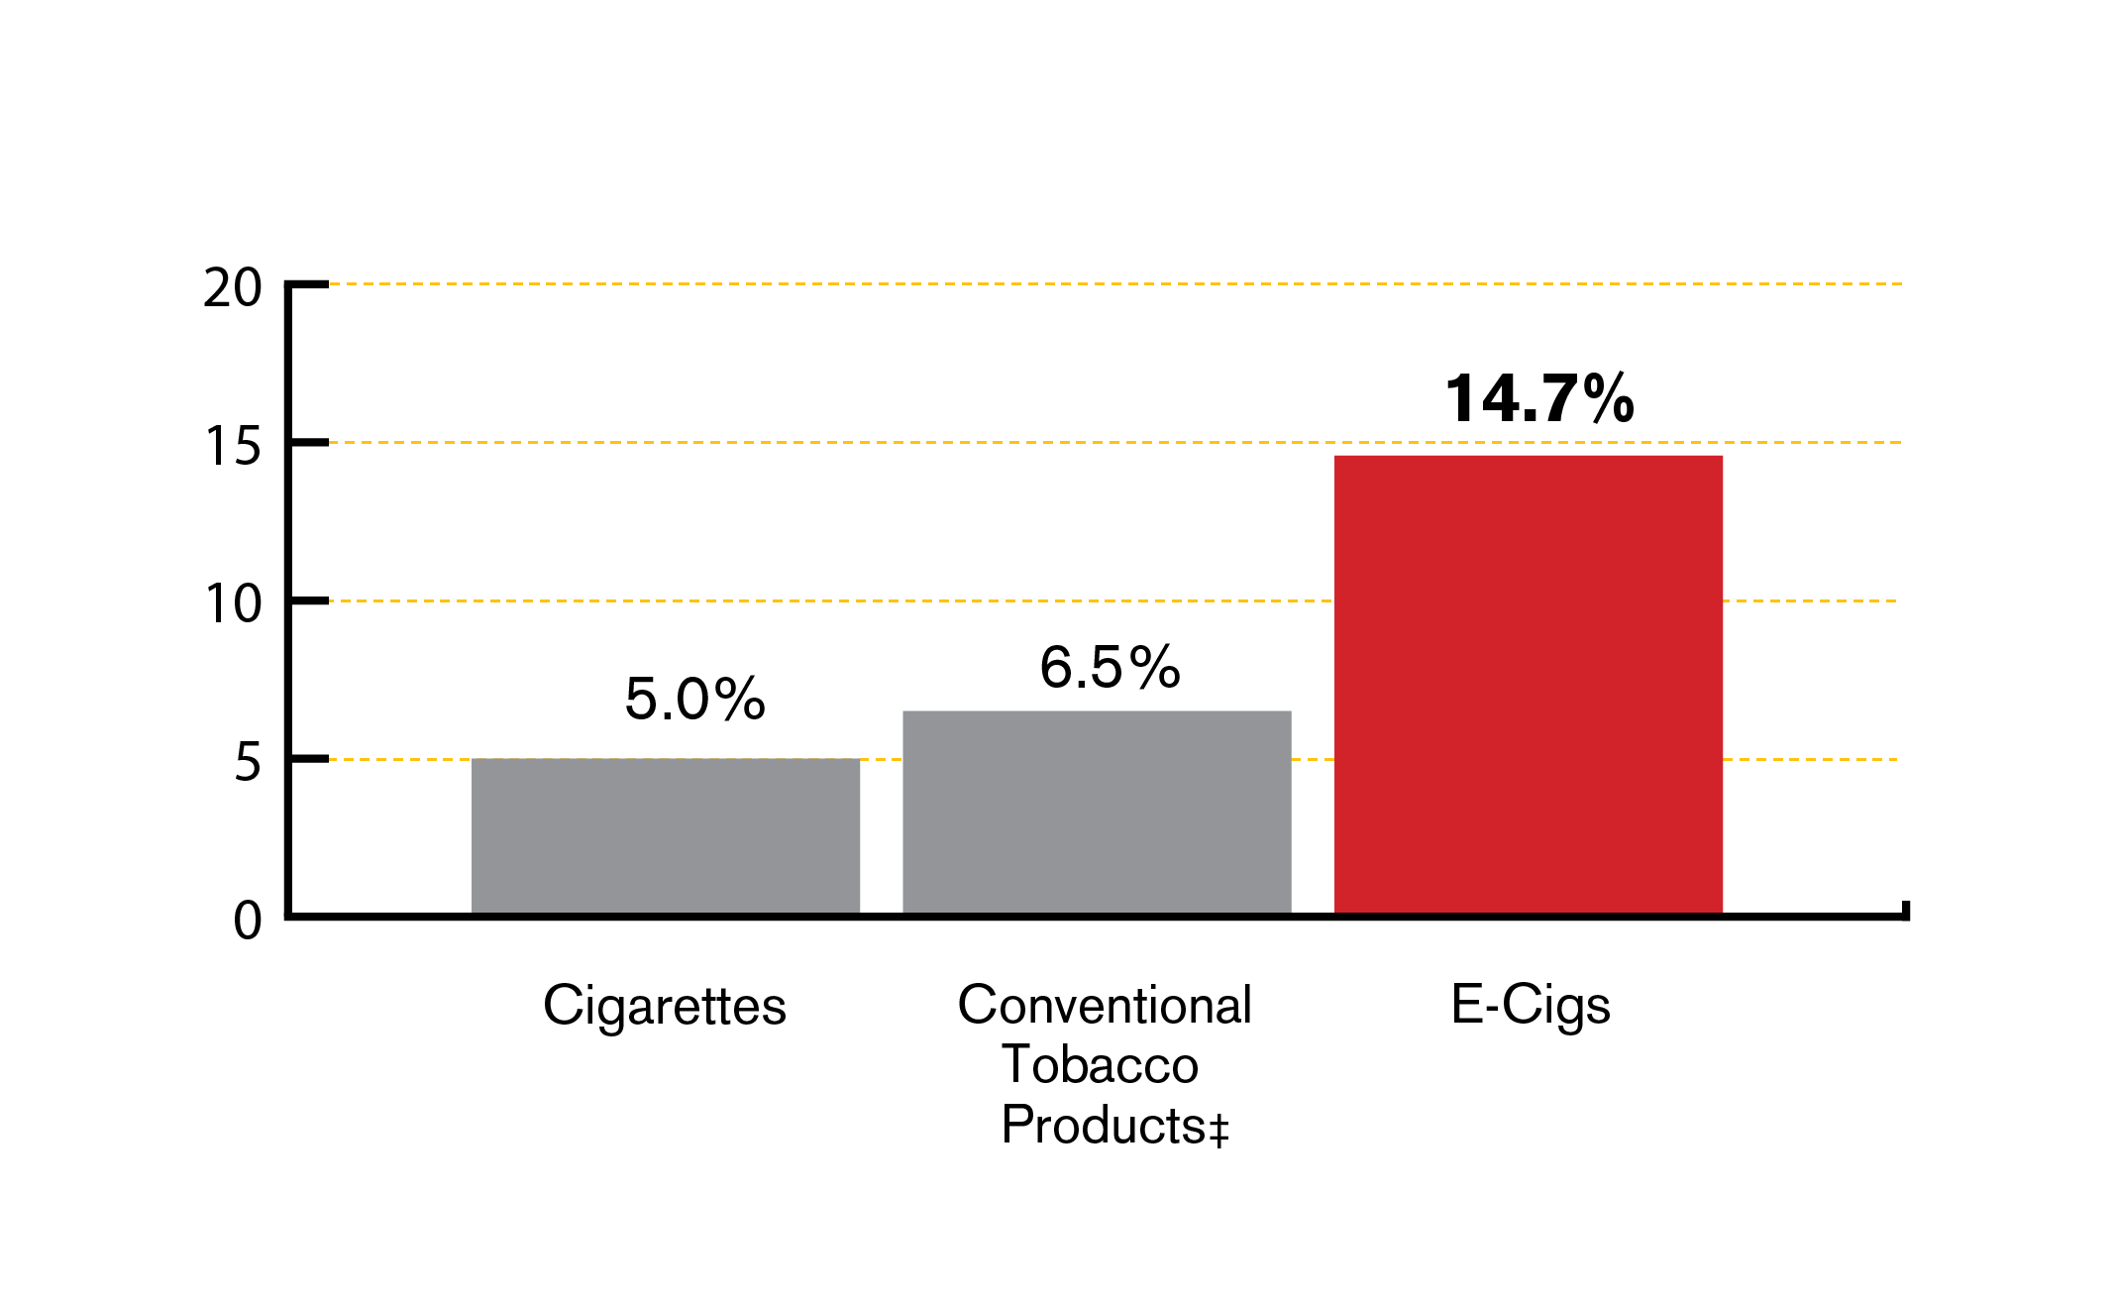 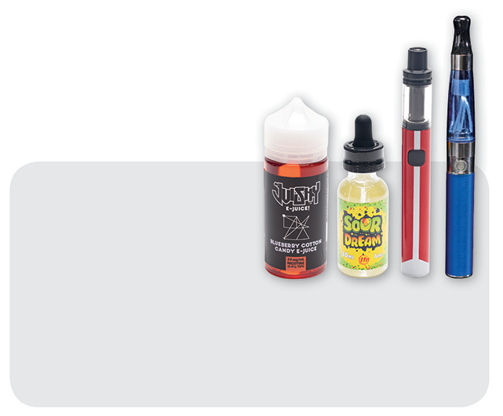 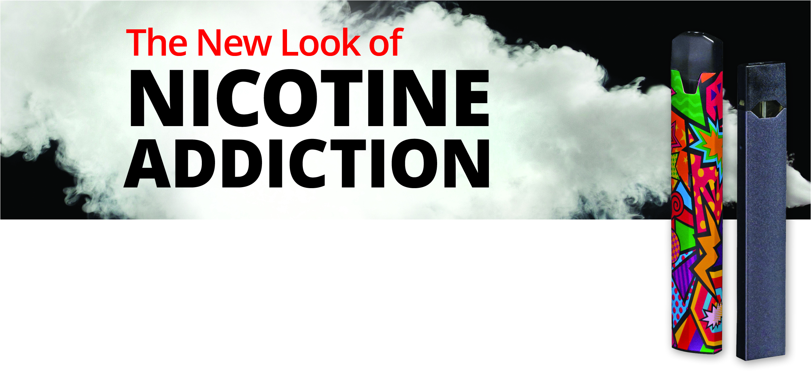

**Ever Use of Tobacco Products**

**Among MA Middle School Students, 2019**

‡ Conventional tobacco is defined as cigarettes, cigars

(including little cigars and cigarillos), and smokeless tobacco (chewing tobacco, snuff, dip)

Source: 2019 MA Youth Health Survey. Data is provisional.

**Title of Talk**

**Date**

**Time**

**Location, including room #**

14.7% of Massachusetts middle school students have tried vapes/e-cigarettes at least once.

Learn more about what these products are, why they are harmful, how to protect our kids, and how to help kids quit.

**Contact**

For questions about the presentation or to register, please contact Name at Phone Number or email address.